HANOI UNIVERSITY OF SCIENCE AND TECHNOLOGY

SCHOOL OF INFORMATION AND COMMUNICATION TECHNOLOGY

========🙡🕮🙣========



***GRADUATION RESEARCH 1***

**PROJECT REPORT:**

Online shop

|  |  |  |
| --- | --- | --- |
| Dương Thị Huê | 20176772 | TT.CNTT ICT 02-K62 |
|  |  |  |
|  |  |  |
|  |  |  |

*Advisor : Nguyễn Hồng Phương*

***Hanoi, June, 2021***

**Contents**

**Objective** 2

**Database (Entity model)** 3

**Class Diagram** 4

**Transition diagram** 8

**Screenshot** 9

# **Objective**

Soda is a shopping online website. Customer can view, make an order and track order. Website is built in client-server model, with Reactjs for frontend, dotNet core with backend and sql server for storing data. Website have customer-side and admine side with simple function because of time limitation.

More detail about technology

* Frontend:
  + Reactjs and antd library to create UI
  + Theme that I consult is from https://themeforest.net/
* Backend
  + Entity framework- database first
  + OOP
  + Swagger
* Storage
  + sql server local

Functionality of Soda

* Login, Signup
* Filter by category, price, name
* View Product by category
* View detail product
* Add, update, delete item into cart
* View cart
* Make an order
* Track order
* Create product
* Edit product
* Delete product
* Edit order
* Filter product by name
* Filter order by receiver name and state
* View Detail Order

# **Database (Entity model)**

To storing user data, I use sql server, database schema that I built is not in 3NF form, however it will improve the response time comparing with 3NF form

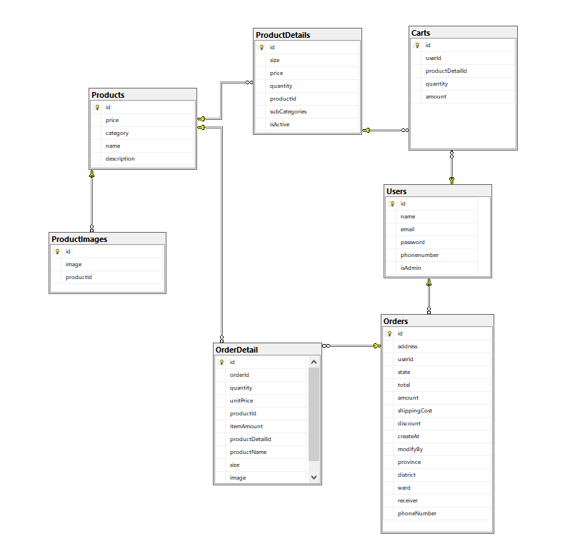

# **Class Diagram**

I divide the class base on package and their functionality

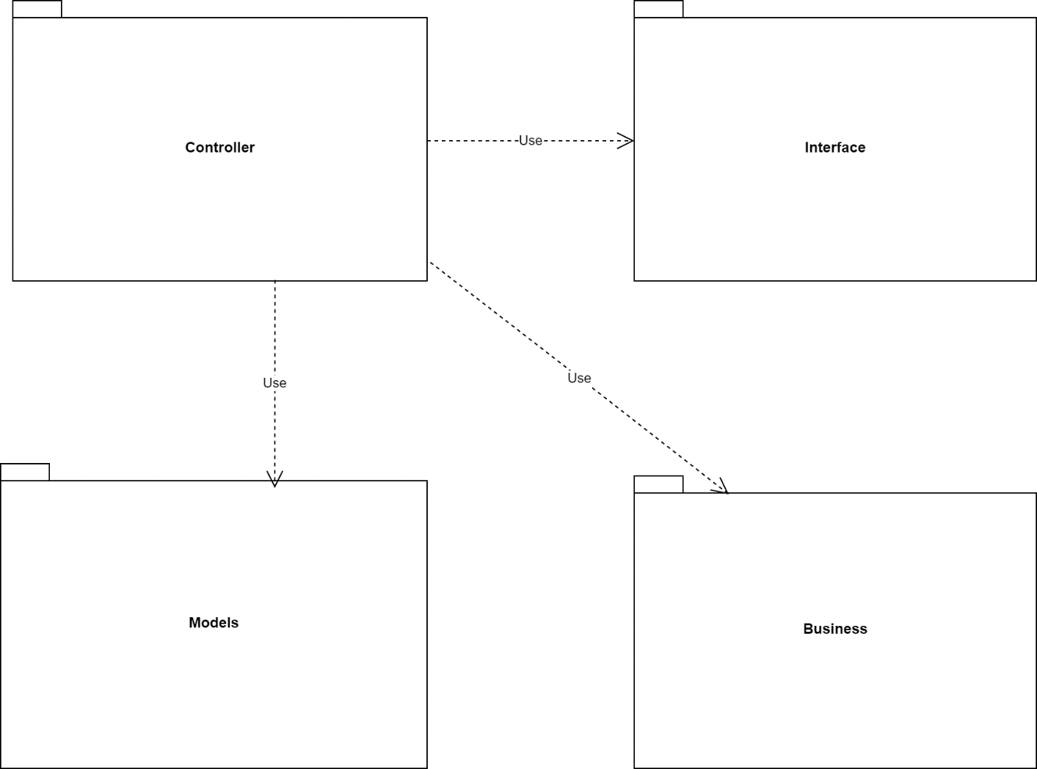

Because it is so big and complicated, I divided it into small diagrams.

* Controller package: contain all class to process all logic requirement

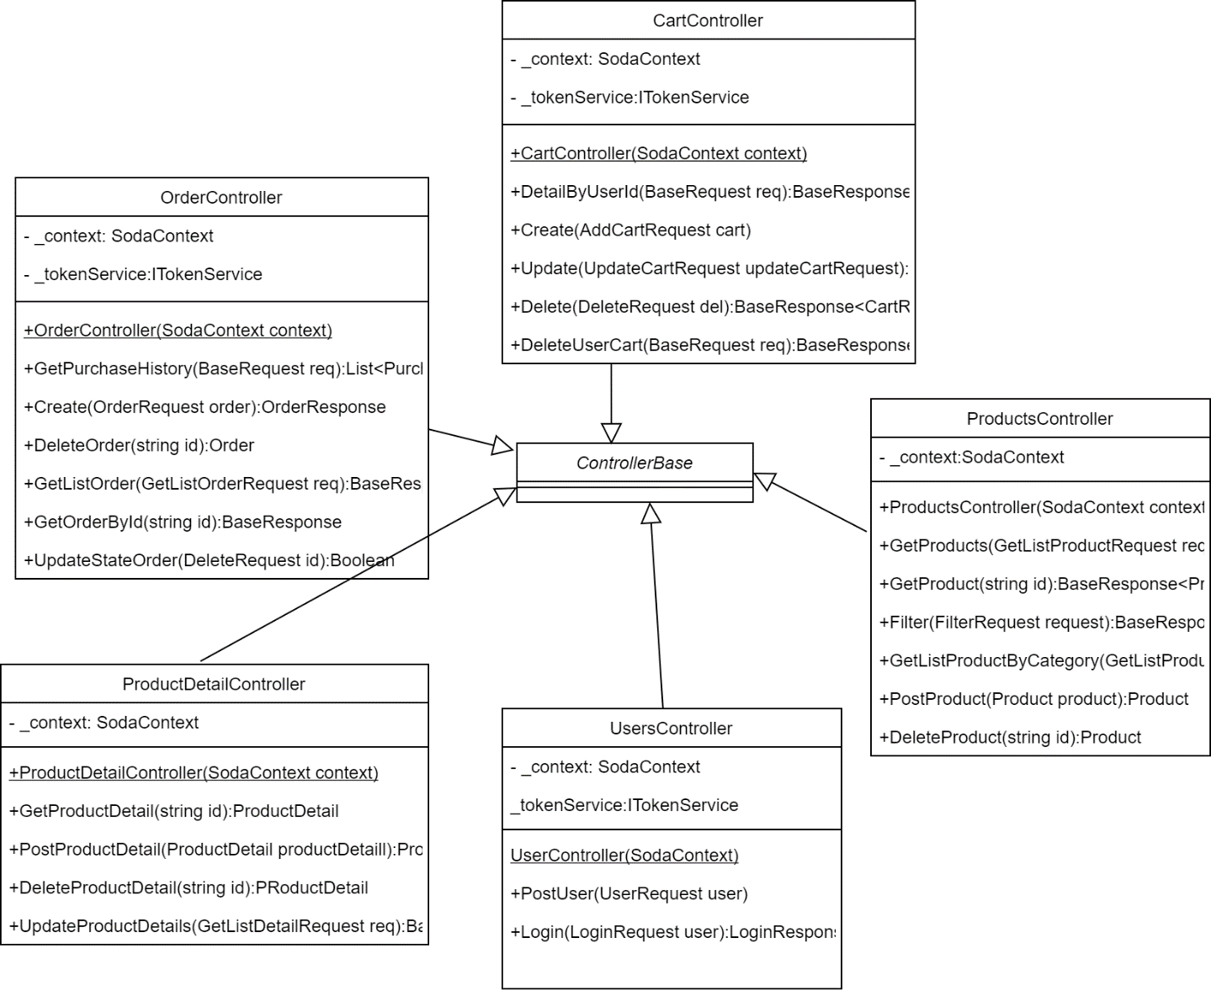

They ‘re extend controller base class which is class of mvc package. All controller class has context attribute whose type is SodaContext. This attribute for connect to database, storing database information.

When user signup into system, the password is hash with key =’duong_thi_hue_12345’ and issuer is ‘http://soda.com’ before storing into database. Therefore, when user login into system, server will hash the password in that rule then compare with database. It will prevent attacker having all user account when database is leaked.

ITokenService is an interface to work with token, to authentic user. Token controller implement ITokenService, I create a simple token bases on user id and user name by hashing them in SHA265. Because I am not good at security, this token is not change in different session of user, so I need to create an system to generate token changeable per session.

User after login into system will receive token and user information without password. I stored the token, username, user id, user phone number in local storage, so that I can use it whenever user send request to server for authenticate.

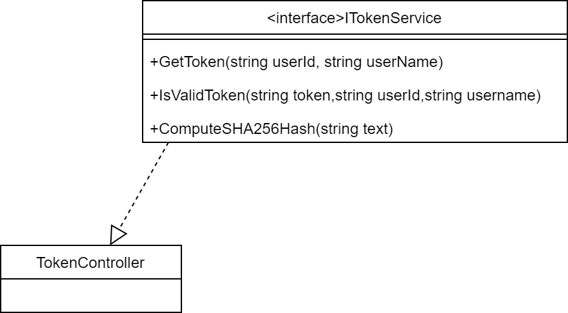

* Business package: contain all request and response data

Request Class

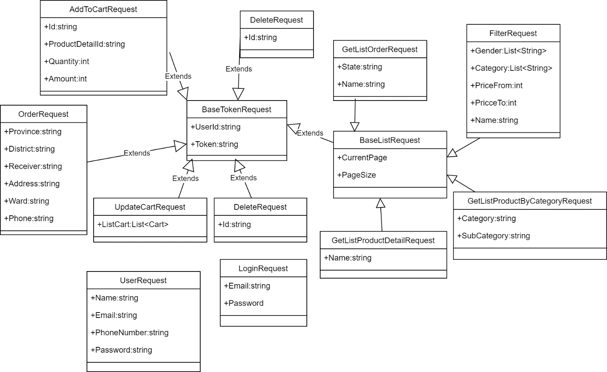

Response Class

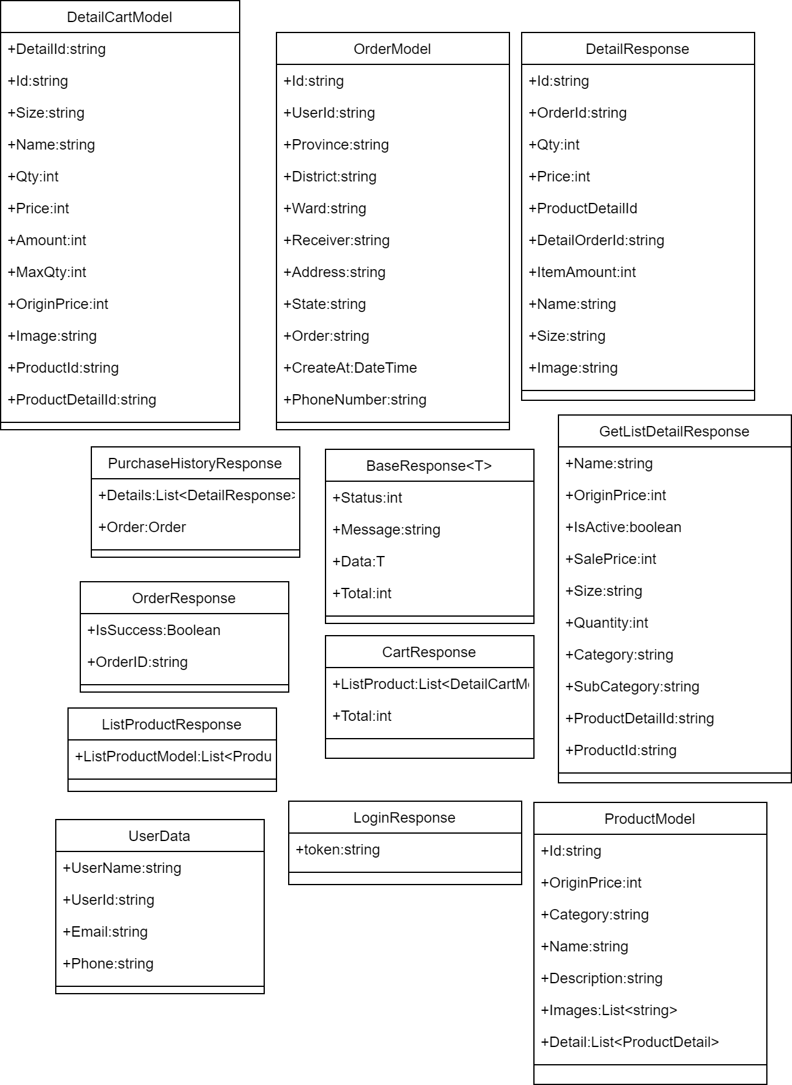

Both request and response have base class corresponding.

Request base class: baseTokenRequest for authentic actor: include user id and token

The class baseListRequest for request a list data: include current page number, page size extend baseTokenRequest

For the response base class, it has status, message returning, total data size and return data. All response inherit this class. In some case, I return the entity model.

* Model package: contain all class work with database

Because I use database first model, the model is generated following the database design.

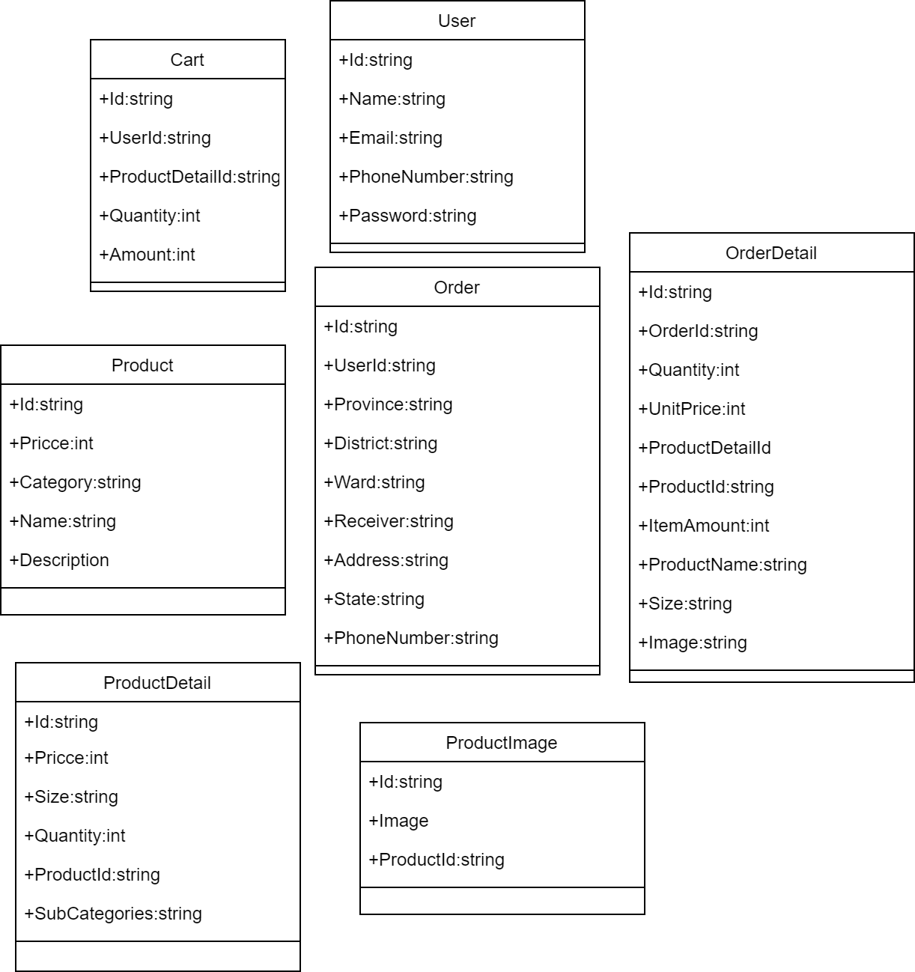

# **Transition diagram**

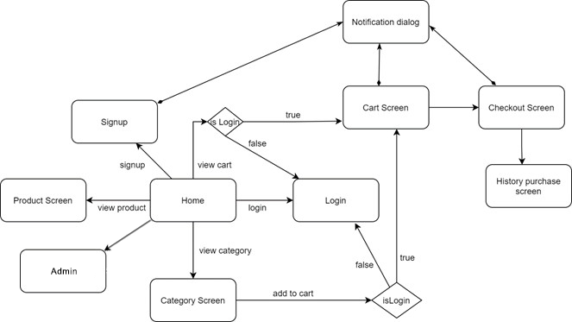

Above is transition diagram. From home, user can go to signup, product screen, category screen, login screen, and cart screen if he/she logined, admin if he/she is admin. The system will redirect into login if user haven’t login yet, but they want to see the cart screen or adding item into cart.

From home, product screen, category screen user can add item into cart with quantity and size. After request to checkout, user have to input requirement data to place an order. If the request valid, the system will direct to history purchase which show the list order and their state. All screen have the notification dialog to show the message result of request, and the screens which have require input have the space to show error position.

Admin side can add product with details, view list order and change state of order, also can update and delete specific product and order, search product by name, order by receiver name and state.

## **Screenshot**

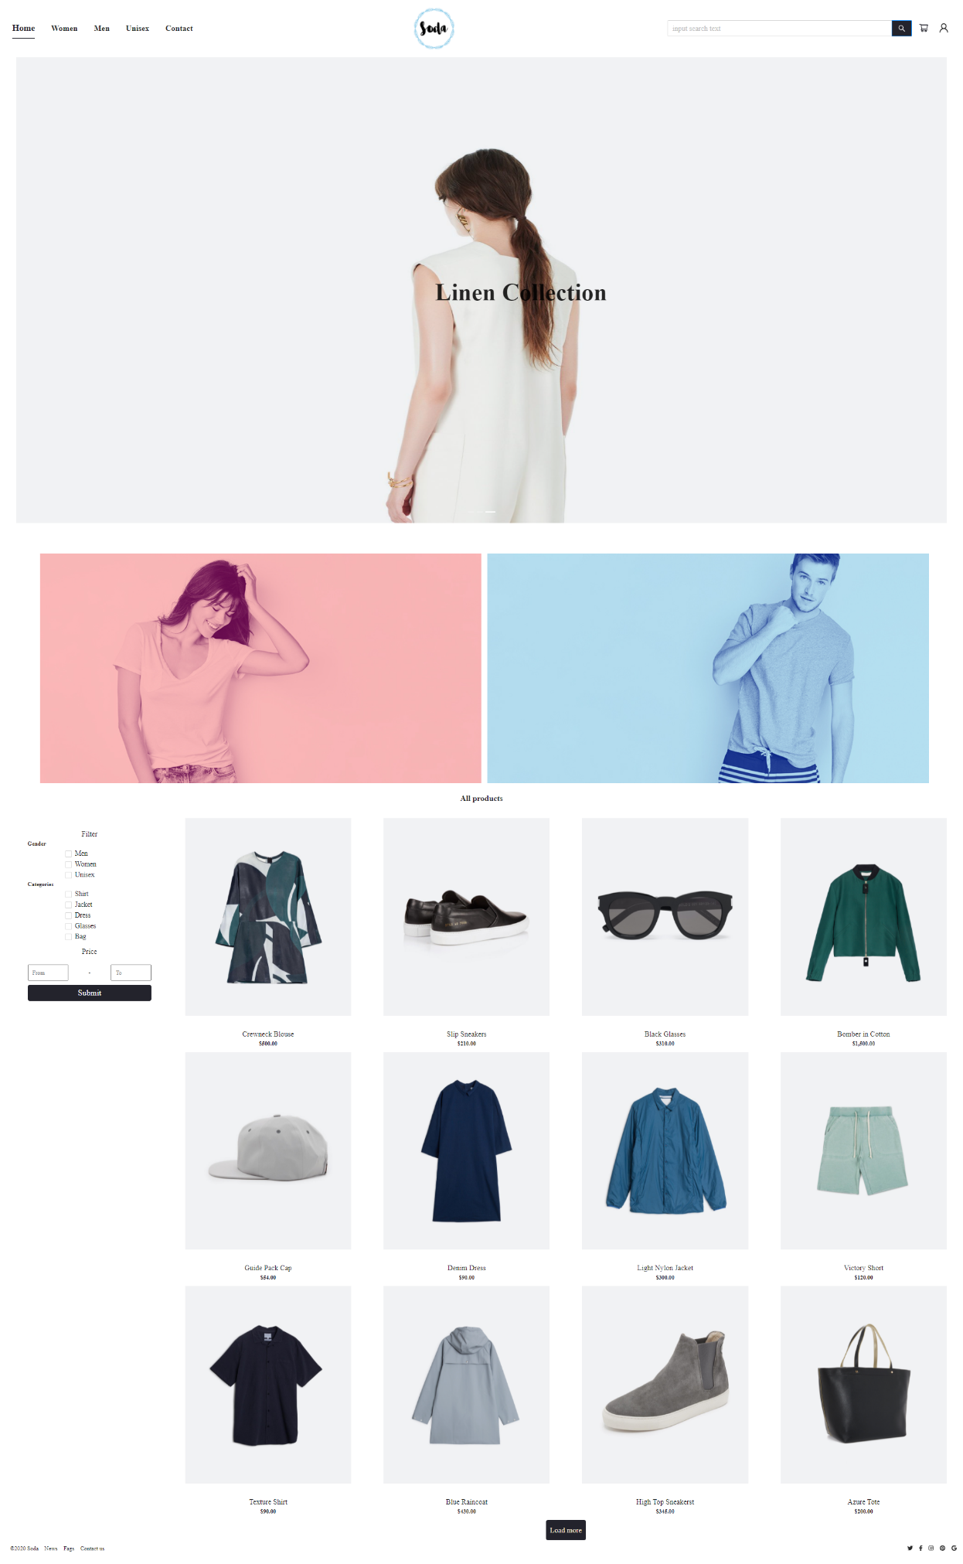When user click on loadmore, more item will be load

Figure 1:Home page

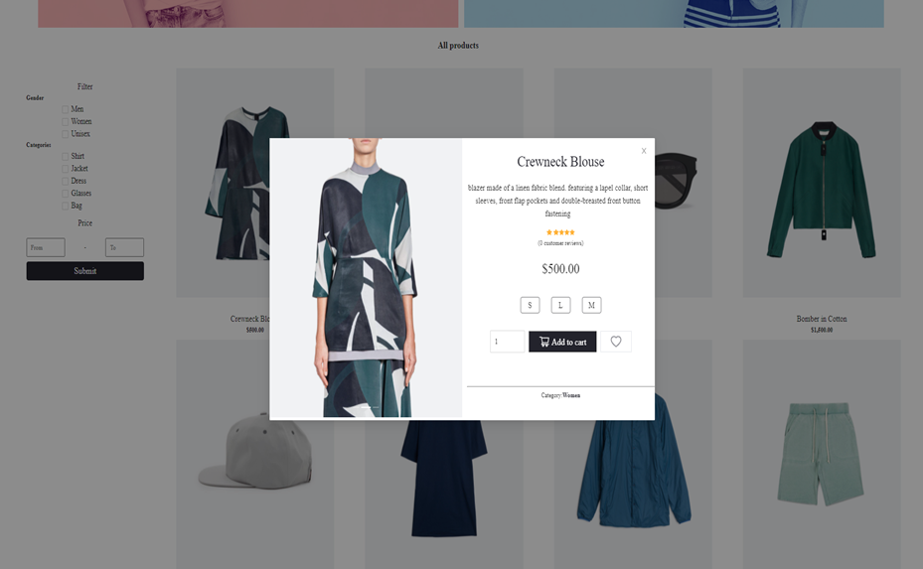

Figure 2:Product dialog

When click into image of the product in home or category page, the dialog will be pop up. User can add item to cart in this dialog

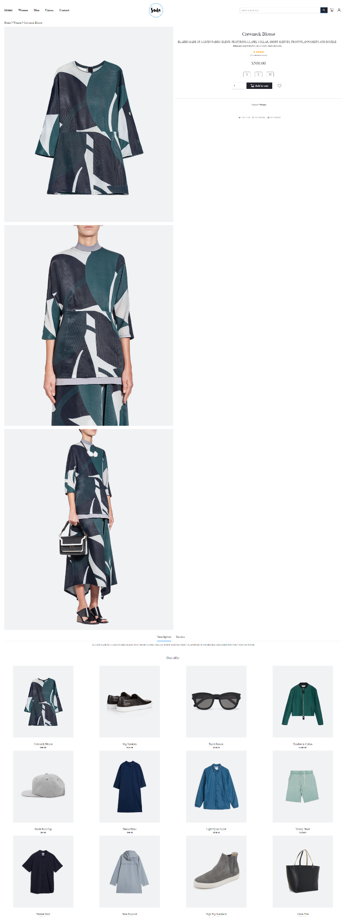

Figure 3:Product page

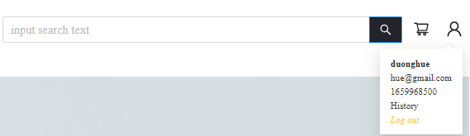

Figure 4:User information

The user information can be seen if user logged into system, else it will be replace by 2 button signup and login as Figure 5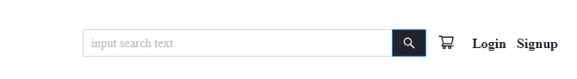

Figure 5:Without login

If user click on product name, it will direct to product view page. In this page use also can add item into cart.

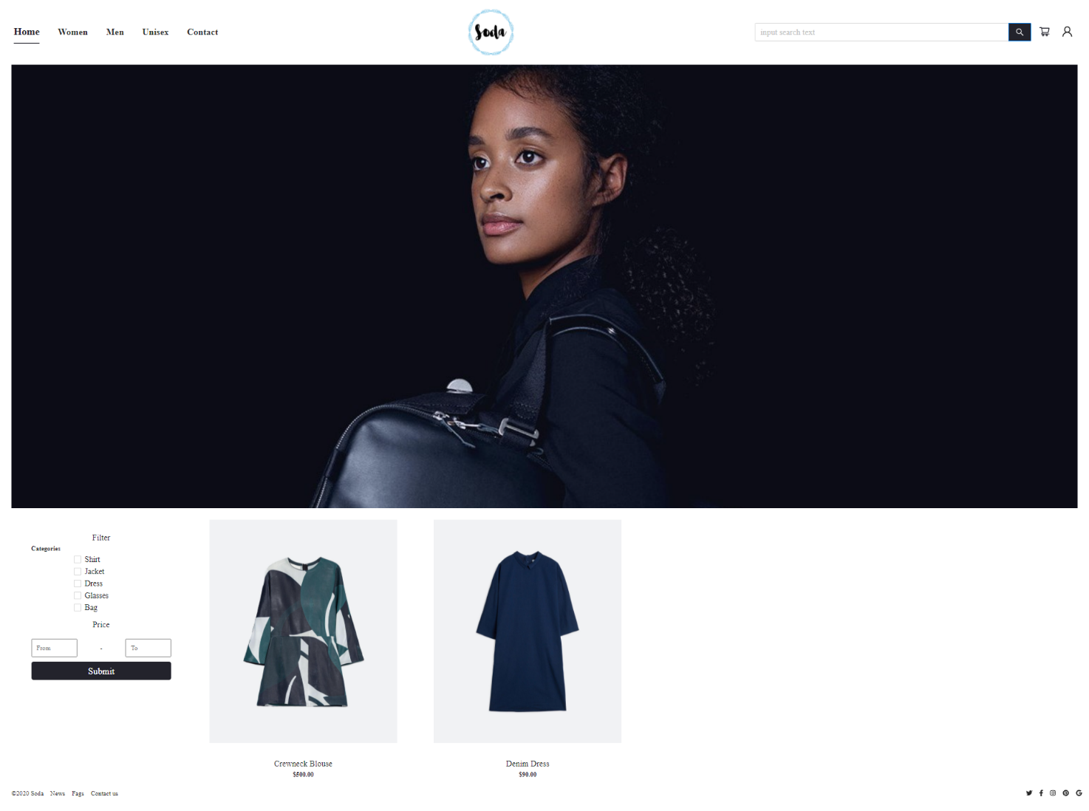

Figure 6:Women category

If user click on the menu to pick women option, application will direct to this page

Similarity with Women category page, below are men category, unisex category and search page

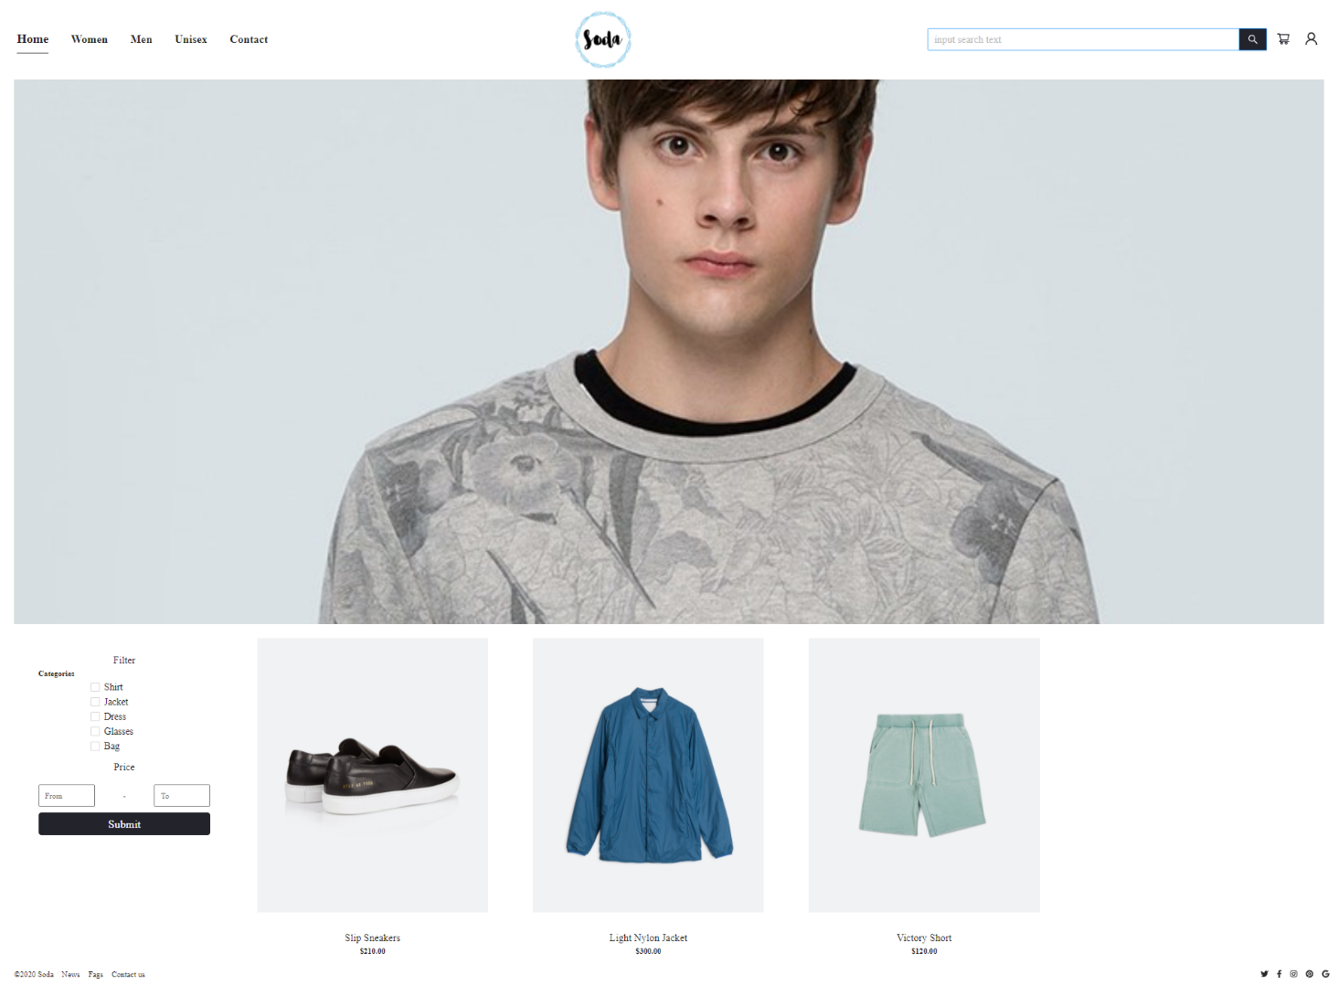

Figure 7:Men page

I also did the filter function, so the screen which have filter can filter item follow the condition

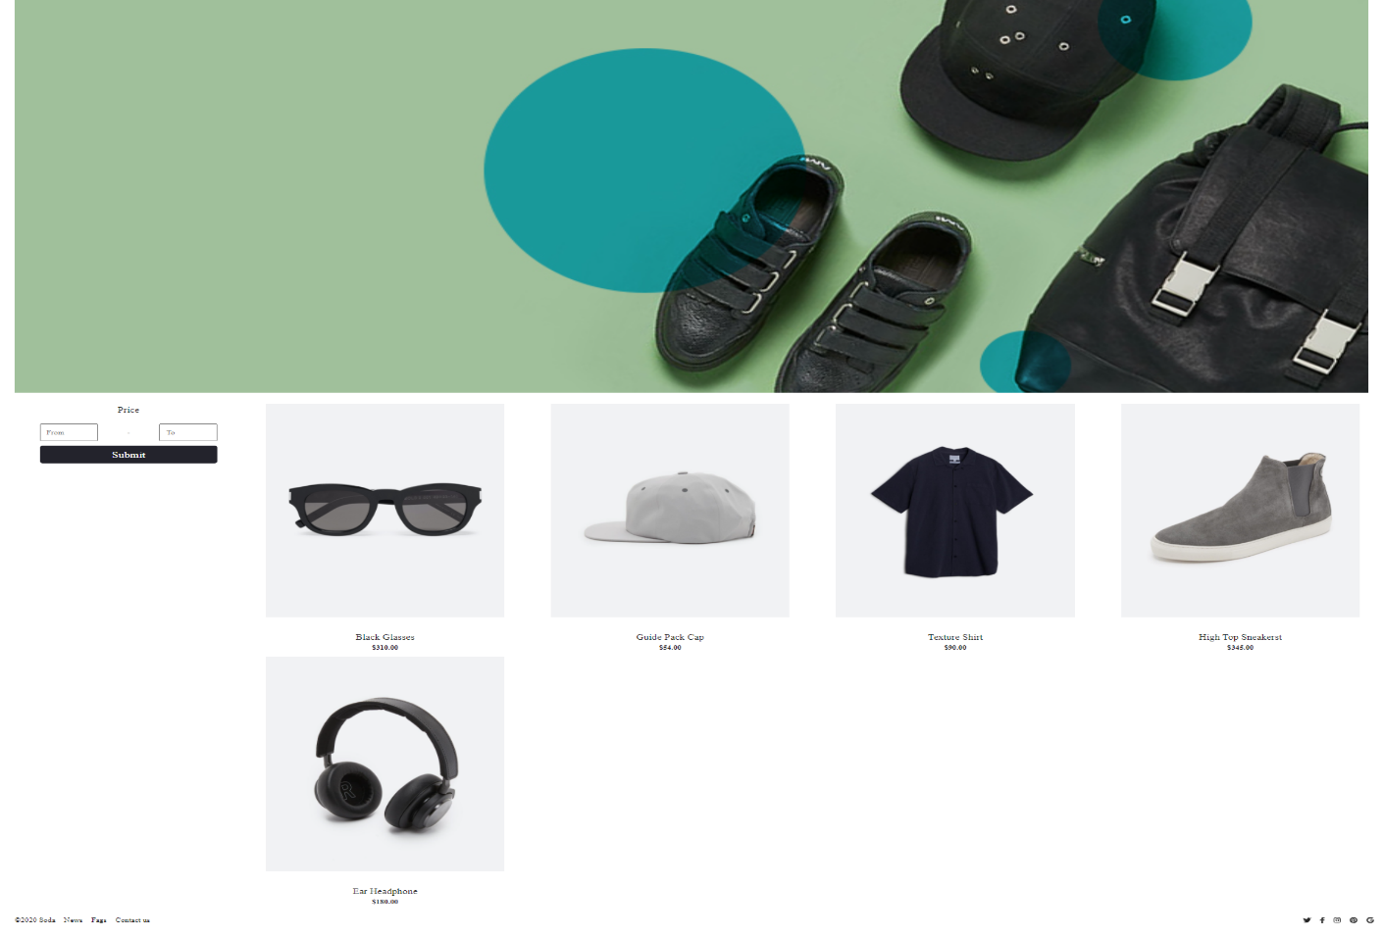

Figure 8:Unisex page

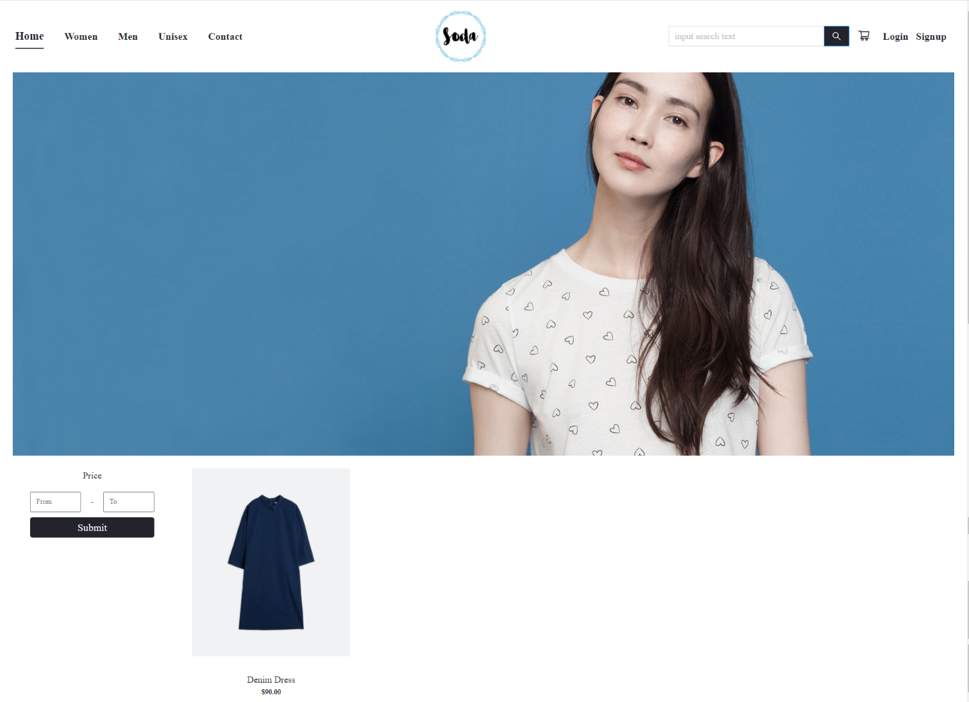

Figure 9:Search page

When user click to cart icon in header, it will be cart screen. The items user insert into cart, size, quantity, price and total are display

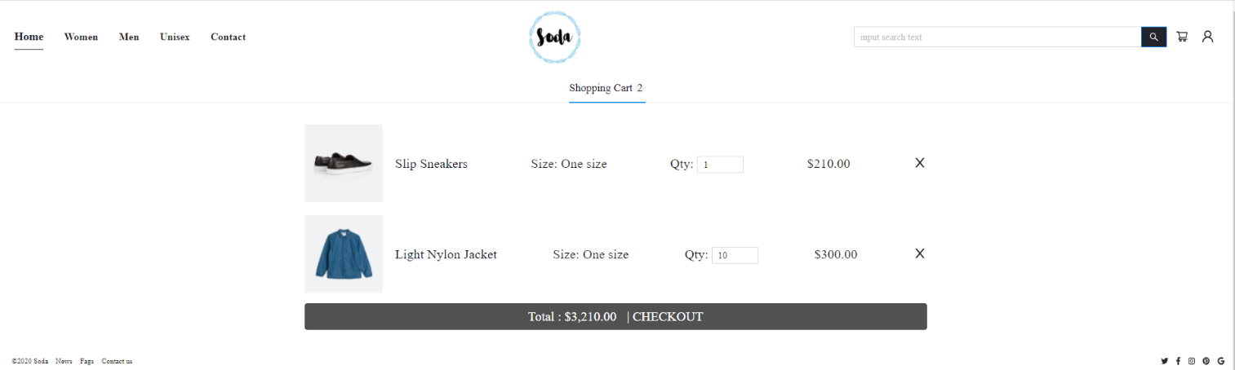

Figure 10:Cart screen

If user click in checkout, it will be checkout screen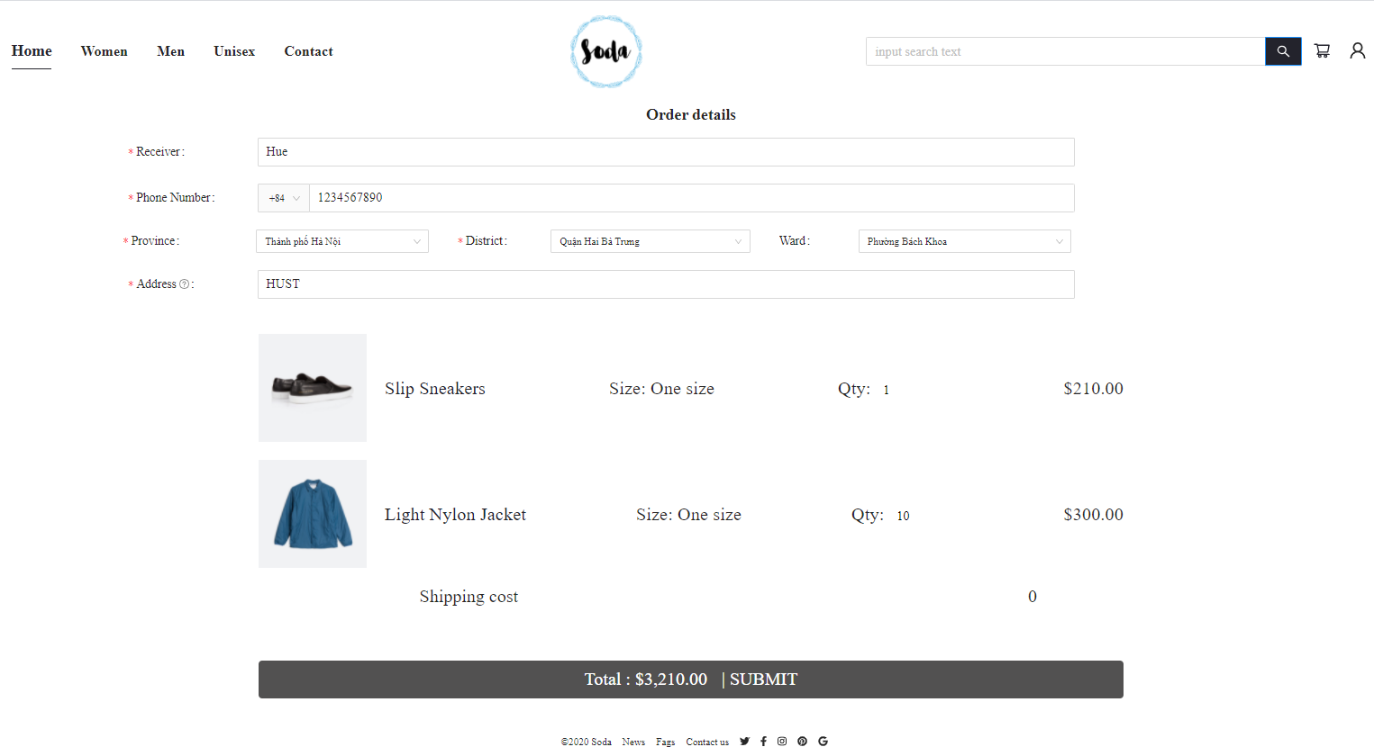

Figure 11:Checkout screen

In this screen user ‘re require to input information for an order, if not it will be

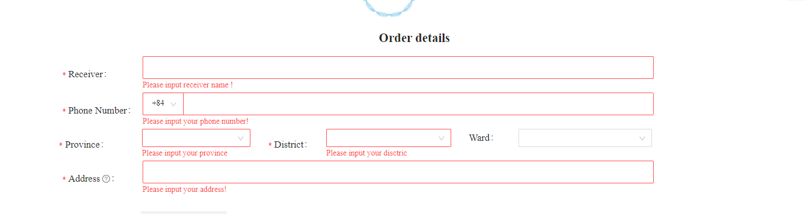

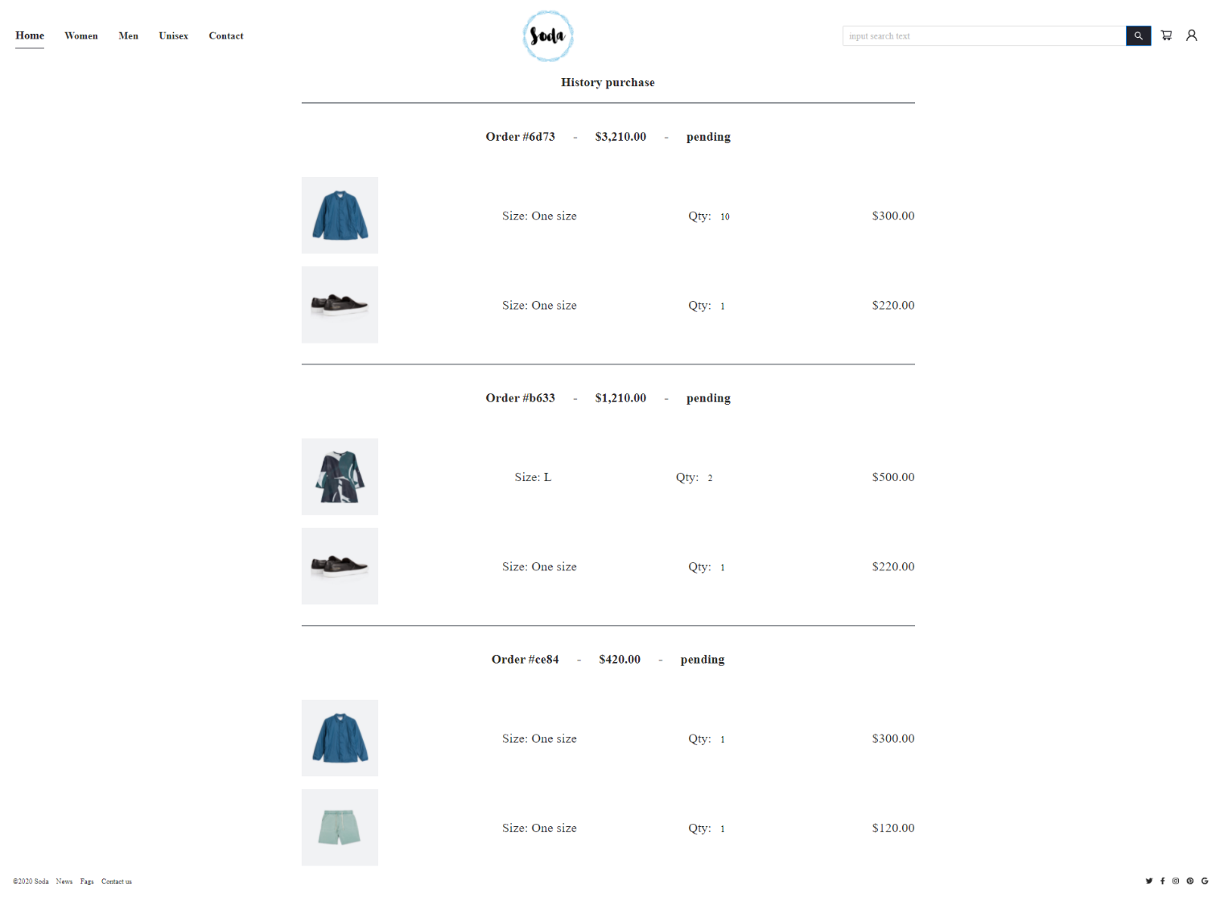

Figure 12:Purchase history screen

If user create order successful, it will direct to purchase history screen. As you can see, the order id, total, and state of it. Because of missing admin site, all order are in pending sate.

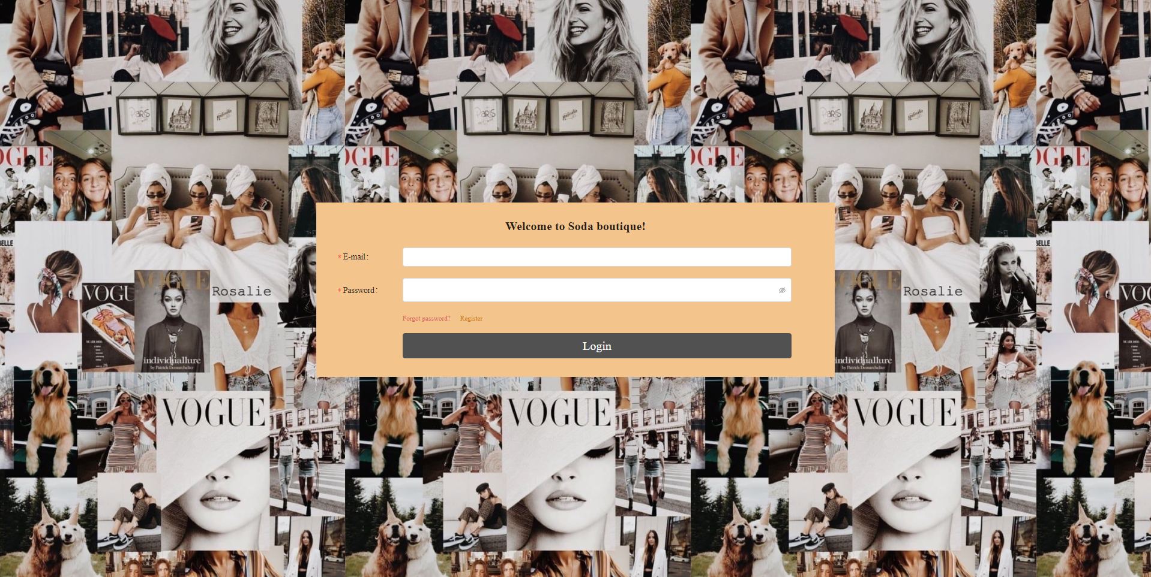

Figure 13:Login screen

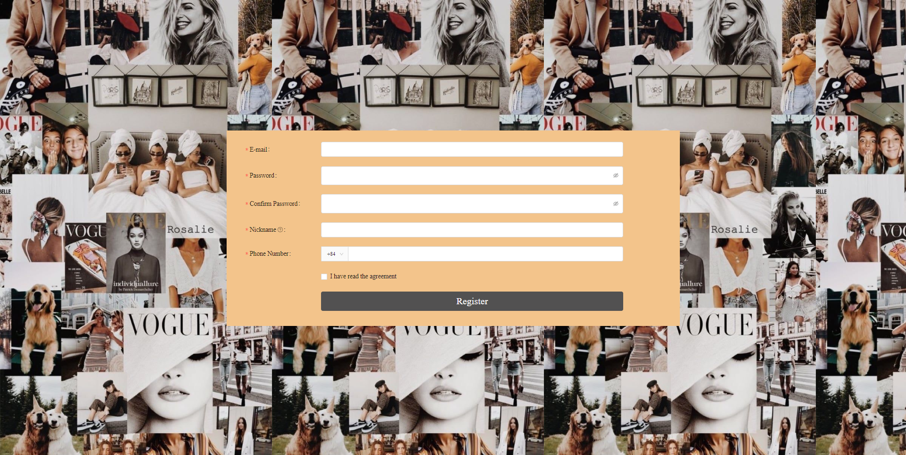

Figure 14:Signup screen

Above is login screen and signup screen.

Below is message dialog, it can be have different content base on error and action

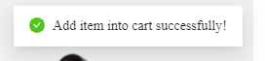

Figure 15:Message successful

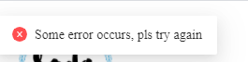

Figure 16:Error message



Figure 17:Mobile screen

I also create friendly screen for mobile, because it is so small and long, I decide to capture only home page.

Admin side

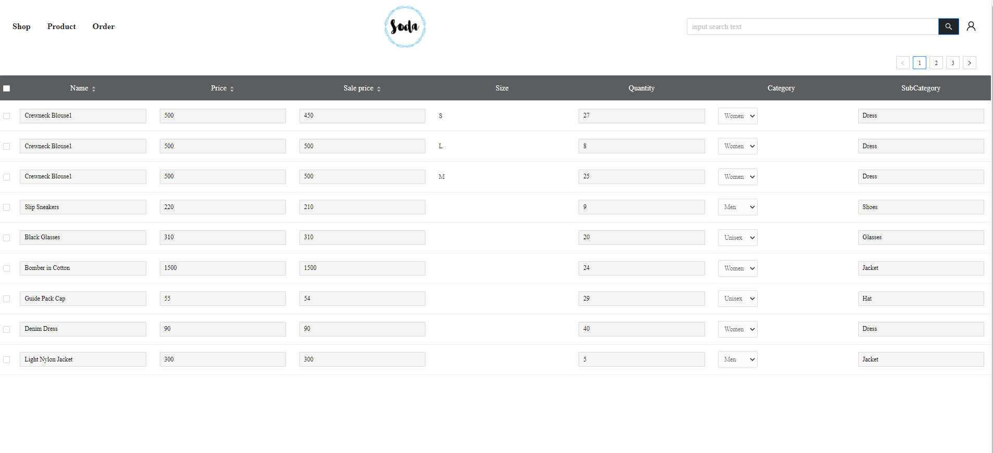

Figure 18:Product list page

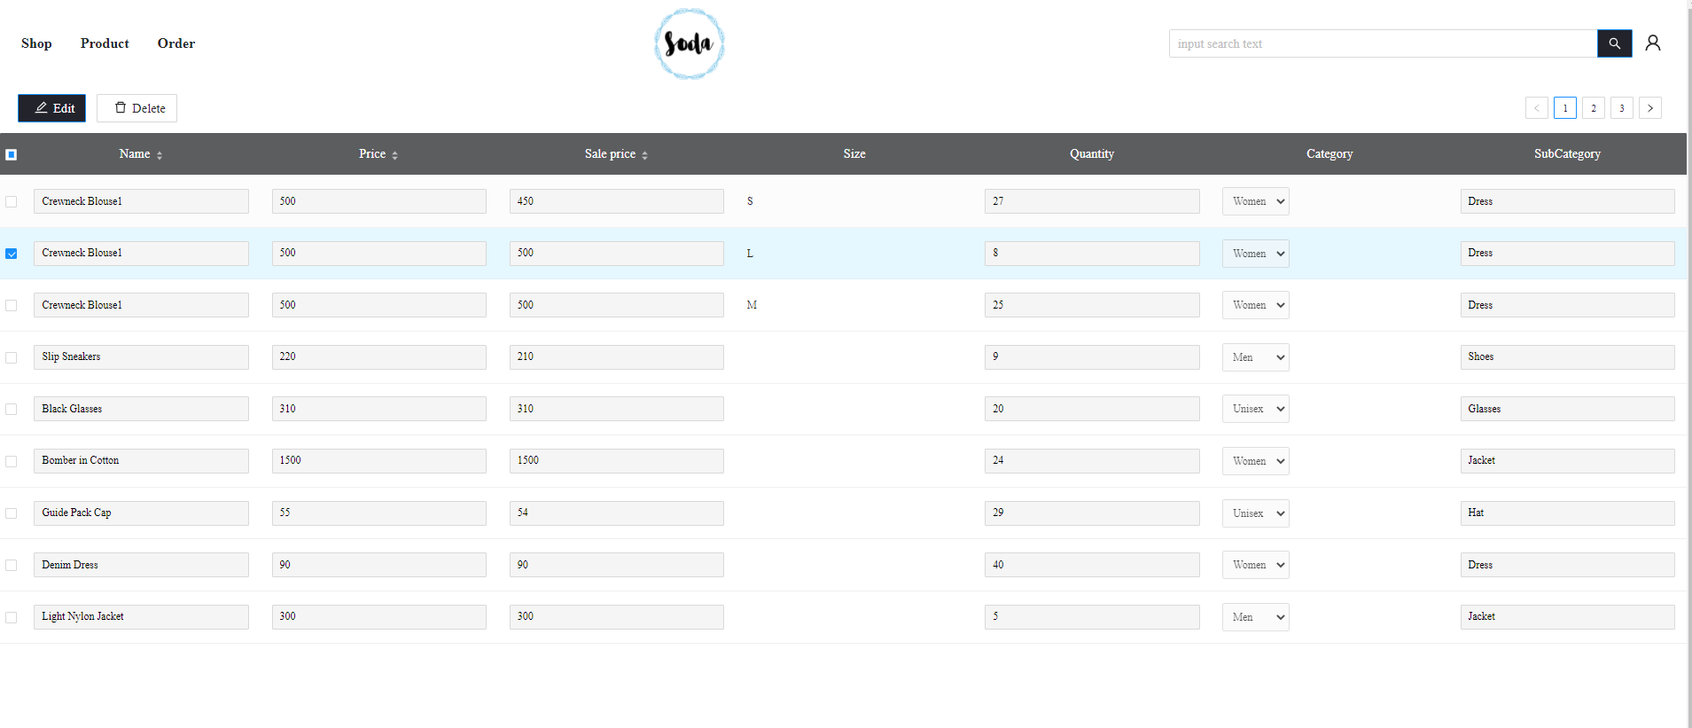

Figure 19:Edit or delete product

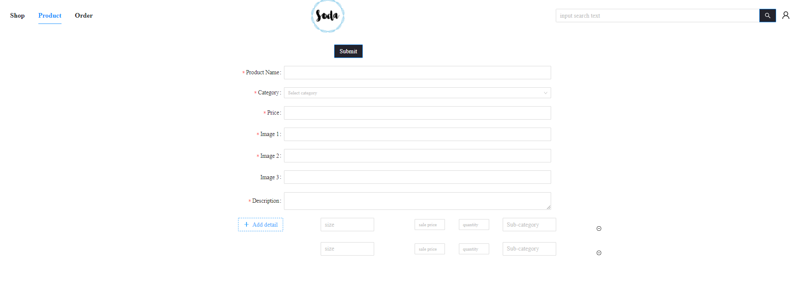

Figure 20:Create a product

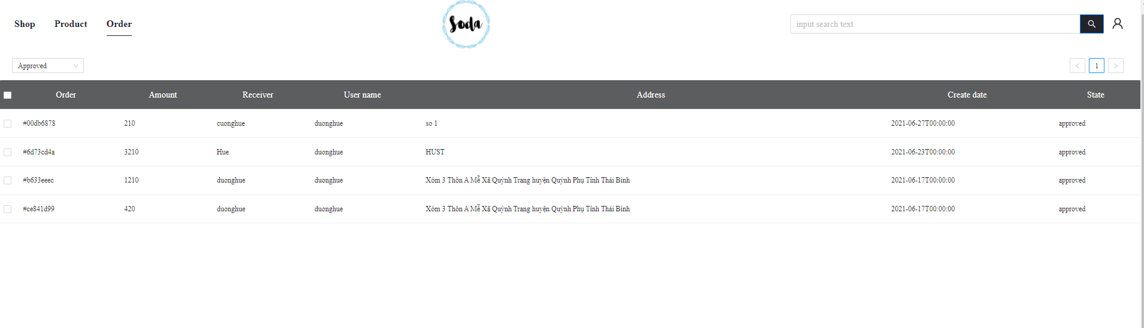

Figure 21: Order list page

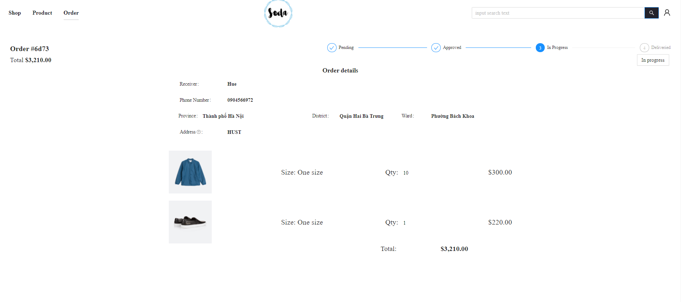

Figure 22:Order view page